**CS 345**

**Project Part 1**

**Database Project Proposal**

As the first part of a five-part project, your group will write a proposal for a database to define via requirements, design, implement and test throughout the semester.

Your proposal should be including the following:

1. An overview/description of the database. Explain the big picture.

**We are creating a database for the Thomas & Rios Gym that will keep track of employees, customers, inventory, payroll, memberships, schedules, etc. This database will help manage the operations of the gym.**

1. Completing ‘needs’ – Justify why the database project should be “funded” (i.e., why it would be useful and to whom).

**A new gym is opening in our area and creating a custom database will aid in keeping track of the operations of the business like building reports to understand how the gym is performing. The database will make it more efficient for creating reports and reducing the amount of work required to build this reports if they had to be created manually from a physical paper file system.**

1. End users' groups – Typically, most databases have users that are interested in different yet related information, and have different privileges for accessing/interacting with the data. Your group must identify **at least two** groups of users and explain how their interactions with the database will differ.

**Management will have access to the entire database to view employee performance, read and write access to modify the schedules, member’s attendance, and payroll. In addition, to having access to inventory and being able to order new equipment.**

**Non-management employee will be able to view their schedule and sign up customers for membership subscriptions. Employees will be able to view their payroll.**

1. Entities and corresponding data sources – Your group must identify **at least 6** entities and explain where the data to populate these tables would come from. (Note: You may make up data when it’s time to actually implement it, but think conceptually here. For example, you may have a Student entity and the data source would come from NAU Students enrolled in CS345, but during implementation you can make up this data, e.g., Joe Smith with student ID #12345). Your group should also discuss the interesting characteristics (i.e., attributes) for each entity.

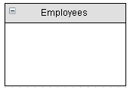 The employees table will have employee information like First Name, Last Name, address, phone number, SSN, DOB, and Position.

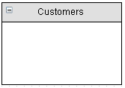 The customers table will contain First Name, Last Name, an email address, and phone number.

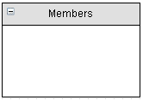 The members table will contain information related to customers that have subscribe to the gym. The table will contain a Subscription Period, First Name, Last Name, DOB, email address, phone number, physical address, and assigned trainer.

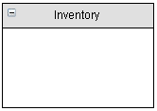 The inventory table will contain information of all equipment that is currently in the gym. The table will contain a date equipment was bought and when maintenance is required, cost of equipment, manufacture maintenance number.

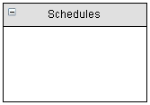 The schedules table will contain the date and time an employee is schedule to work.

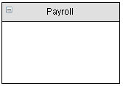

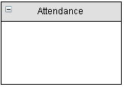

1. Relationships - Your group must identify **at least two of each of type** of relationship we’ve discussed (i.e., 1:1, 1:M, M:N) to be implemented. All relationships need to be stated in English sentences from a bi-directional perspective (e.g., For a 1:M relationship between owners and bikes - Each owner has 1 or more bikes. Each bike has only one owner.)